

***Palestine technical university – kadoorie***

***College of engineering and Technology***

***Department of computer Engineering***

***Course Name:***

***Software Engineering***

***Project Title:***

***E-parking management system***

***By:***

***Aya Musamih***

***Lamees Ballan***

***Supervisor:***

***Dr. Osama Hamed***

Second semester 2024/2025

Table of Contents for an SRS Document

***1. Introduction***

1.1 purpose

1.2 Document Conventions

1.3 Intended Audience and Reading Suggestions

1.4 Project Scope

1.5 References

***2. Overall Description***

2.1 Product Perspective

2.2 Product Features

2.3 User Classes and Characteristics

2.4 Operating Environment

2.5 Design and Implementation Constraints

2.6 Assumptions and Dependencies

***3. System Features***

3.1 Functional Requirements

Table of Contents for a SRS Document

***4. External Interface Requirements***

4.1 User Interfaces

4.2 Hardware Interfaces

4.3 Software Interfaces

4.4 Communications Interfaces

***5. Nonfunctional Requirements***

5.1 Performance Requirements

5.2 Safety Requirements

5.3 Security Requirements

5.4 Software Quality Attributes

***1.Introduction***

**The E-Parking management system is designed to streamline the process of monitoring the entry and exit of vehicles in a parking facility. This system allows administrators easy access to vehicle records through license plate numbers, enhancing the efficiency of data retrieval. In numerous public areas such as shopping malls, entertainment complexes, hospitals, office buildings, and marketplaces, parking remains a significant challenge. Parking spaces are spread across various lanes or slots, requiring drivers to search multiple lanes to find a spot. This not only consumes time but also requires substantial manual effort and financial resources. By providing a safer, more secure, and cost-effective parking solution, our system aims to alleviate the need for vehicles to be towed due to improper parking.**

**1.1 purpose**

**أعلى النموذج**

**By subscribing to our service, vehicle owners can secure their own parking slots through payment, effectively eliminating the risk of towing. This ensures that vehicles are parked safely and securely, removing any concern for owners about finding parking or the safety of their vehicle. In the event of any damage or issues, the parking management will be responsible for addressing claims, offering an added layer of security for vehicle owners.**

**1.2 Document Conventions**

**Abbreviation Explanation**

------------------------------------------------------

**API Application programming Interface**

**EPMS E parking management system**

**GUI Graphical user interface**

**IDE Integrated development environment**

**IT Information technology**

**OS Operating system**

**SQL Structure query language**

**1.3 Intended Audience and Reading Suggestions**

**This document serves as a comprehensive resource on the Electronic Parking Management System (E-PMS), detailing its operational requirements, functionalities, features, and the innovative technologies it employs. It is designed to ensure clarity and direction in the development and deployment of E-PMS, ensuring that it functions safely and effectively. For developers, this document is essential as it confirms they are working on the correct project. Testers rely on this document for a precise inventory of the system's features and functions. And absolutely for users, this document offers an introduction to the project's concept, encouraging them to understand its functionality and potential.**

**1.4 Project Scope**

**In today's world, as cities grow and more people own vehicles, there's a big need for parking spaces at places like offices, malls, hospitals, and schools.**

**Our Vehicle Parking Management System is an automatic setup that processes data quickly and systematically, making it easier for any organization to keep track of parked vehicles. It's designed to solve the challenge of managing parking spaces efficiently by recording when vehicles come in and go out, helping to make the most of available parking. As the need for parking management grows, our system offers a simple solution to help organizations manage their parking spaces better.**

**1.5 References**

<https://www.fresh222.com/car-parking-management-system/>

<https://www.mantratec.com/Solutions/Parking-Management-System>

<https://krazytech.com/projects/sample-software-requirements-specificationsrs-report-airline-database>

https://mermaid.js.org/syntax/entityRelationshipDiagram.html

***5. Nonfunctional Requirements***

***5.1* Performance Requirements**

**The steps involved to perform the implementation of the parking management system are listed below**

1. **E-R DIAGRAM**

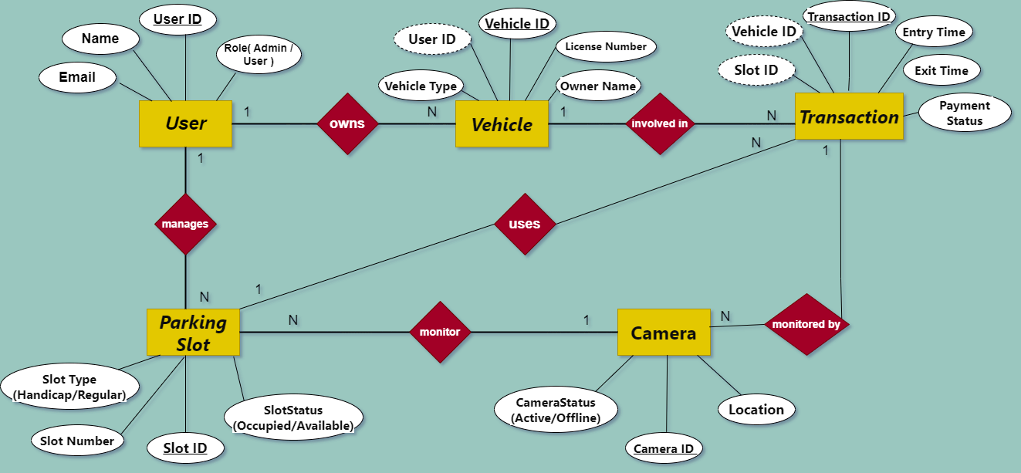**ER diagram is visual representation of data that describes how data is communicated and related to each other.  
Use of ER diagram:  
a) It provides a preview of how table should be connected what fields are going to be on each table.  
b) It allows you to communicate logical structure of database to user.**

**B) NORMALIZATION:**

**NORMALIZATION is the process of reorganizing data in database to meet two basic requirements:  
a) There is no redundancy of data (all data are stored in one place)  
b) Data Dependencies are logical (all related data items are stored together). It is also known as Data Normalization.**